Projects in ArgoCD allow you to group applications, enforce access controls, and restrict source/destination clusters and namespaces.
Via the ArgoCD UI
- Go to Settings → Projects
- Click Create Project

Description | Workshop project for nginx deployment
Source Repositories | *
Destinations (Cluster) | *
Destinations (Namespace | *
- Click Create. The project is now active and visible in the Projects list.
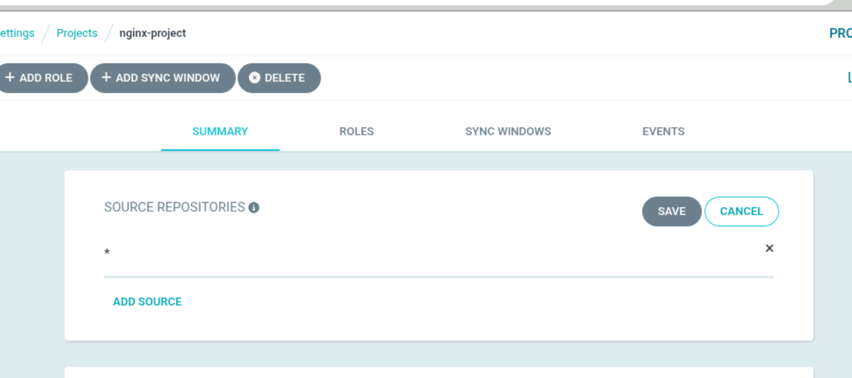

Cluster allow list

